**Mark Twain School for Scholars**

**12800 Visger, Detroit, MI 48217**

**Office: 313-386-5530; Fax: 313-386-5965**

**Dr. Jemel M. Hence, Principal**

**Mrs. Jessica L. Gunter, Assistant Principal**

**2023-2024 Uniforms where we Dress for Success!**

**Tops**

**K-5th Grade**

* Solid color, polo, or button-down shirt with a collar **(Navy Blue or Black)**
* Sweaters **(Navy Blue or Black)**

**6th- 8th Grade**

* **6-8,** Solid color, polo, or button-down shirt with a collar **(Gold, Yellow or White)**
* Sweaters **(Navy Blue or Black)**

**All Grades**

* Mark Twain T-Shirt can be worn on **Friday’s only!**

**Bottoms**

**K-8th Grade**

* Slacks **(Navy, Black, Khaki)**
* **Knee-length** skirts, shorts, skorts and jumpers **(Navy, Black, Khaki)**

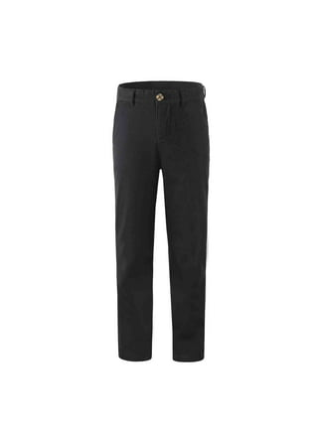

**Footwear**

* Athletic shoes, laced shoes and/or other shoe boots, loafers, or other closed-toed

**Prohibited**

# 

**Students Rise. We All Rise.**

**Mark Twain School for Scholars**

**12800 Visger, Detroit, MI 48217**

**Office: 313-386-5530; Fax: 313-386-5965**

**Dr. Jemel M. Hence, Principal**

**Mrs. Jessica L. Gunter, Assistant Principal**

¡Uniformes 2023-2024 donde nos Vestimos para el Éxito!

Tops

K-5to grado

• Color sólido, polo o camisa abotonada con cuello (azul marino o negra)

• Suéteres (azul marino o negro)

6º- 8º Grado

• 6-8, Color sólido, polo o camisa abotonada con cuello (Dorada, Amarilla o Blanca)

• Suéteres (azul marino o negro)

Todos los grados

• ¡La camiseta de Mark Twain solo se puede usar los viernes!

Fondos 

Grado K-8

• Pantalones (Azul marino, Negro, Caqui)

• Faldas, shorts, falda pantalón y jumpers hasta la rodilla (azul marino, negro, caqui)

Calzado

• Zapatos deportivos, zapatos con cordones y/u otras botas, mocasines u otros zapatos cerrados

Prohibida

gorros, du-rags, gorras, pantalones de chándal, sudaderas con capucha, pantuflas, sandalias, calzas

Los estudiantes se levantan. Todos nos levantamos.

